Gravity and Magnetic Mapping of the Seattle Area

Gravity and magnetic maps are important geologic tools for finding and understanding geological features. The potential fields created by the Earth’s gravity and magnetic field are altered by the heterogeneous composition of the Earth’s crust, and these differences lead to measurable changes in expected or modelled potential fields. These variations in gravity and magnetic fields can be used to look at regional geologic structures and units.

The main factors that affect the gravitational potential are the mass of objects and the distance to them. Corrections based on predicted or known variations in the Earth associated with elevation, latitude, regional trends, and terrain may be made to isolate anomalies of interest. The resulting anomalies are created by depth, with deeper anomalies having longer wavelengths, and density difference, with anomalies of a low density having lower gravity values. These values are typically measured relative to each other and to a location of absolute measurement. In contrast to the monopolar anomalies of gravity, magnetic anomalies are dipolar as a result of general magnetic properties with each anomaly having an associated magnetic high and low point. The shape and orientation of the anomaly is dependent on the field induced by the Earth at the location of the anomaly as a function of latitude, inclination from magnetic North, and declination from horizontal. The amplitude of a magnetic anomaly is based on the magnetic susceptibility of the material, with ferromagnetic and ferrimagnetic being the more susceptible compared to paramagnetic, and the wavelength of the anomaly is affected by its depth in a manner similar to gravity anomalies, with deeper sources having a longer wavelength.

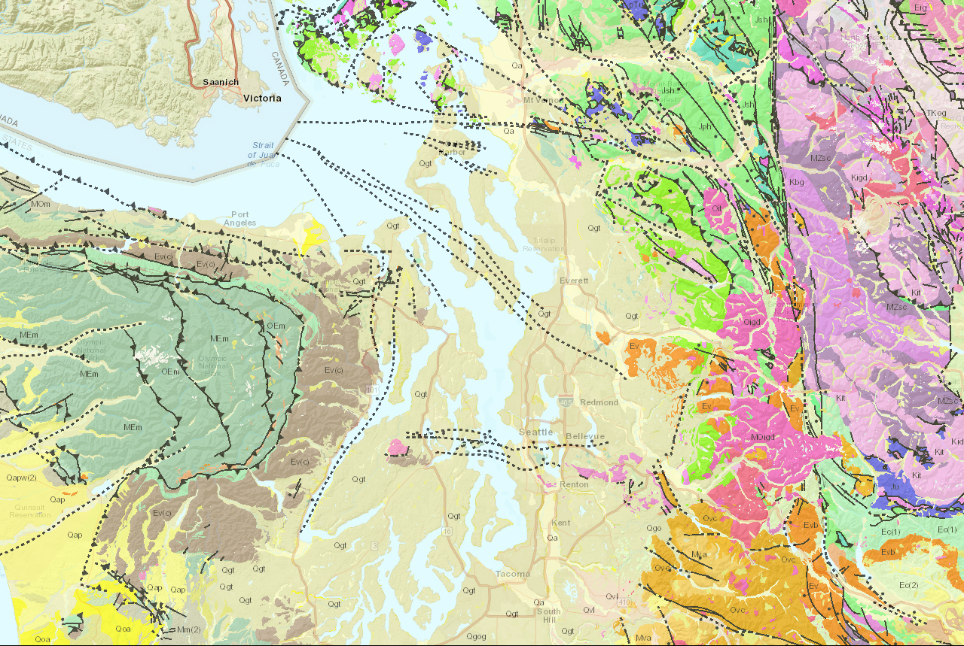 The region around Seattle along the NW coast of Washington has undergone compressional stress as a result of the subduction of the Juan de Fuca plate beneath the North American plate. This has led to a complex arrangement of volcanism and accumulated marine sediments to produce the current geologic features seen in Figure 1. In combination with this, large areas of this compressional history have been covered due to the glacial history, and large areas of the state are covered with glacial outwash and till, such as the region around Seattle. This covering makes finding structural features difficult, but the use of gravity and magnetic maps may be used in combination with the known geology if the area to find potential hazards that may not be visible under Quaternary covering.

Figure 1. Geologic map overlay from the Washington Interactive Geologic Map with units and faults displayed from 1:250,000 scale Geology. Buried faults, most likely determined by potential field methods or drilling, throughout the region can be seen as dashed lines through the Quaternary glacial and alluvial deposits.

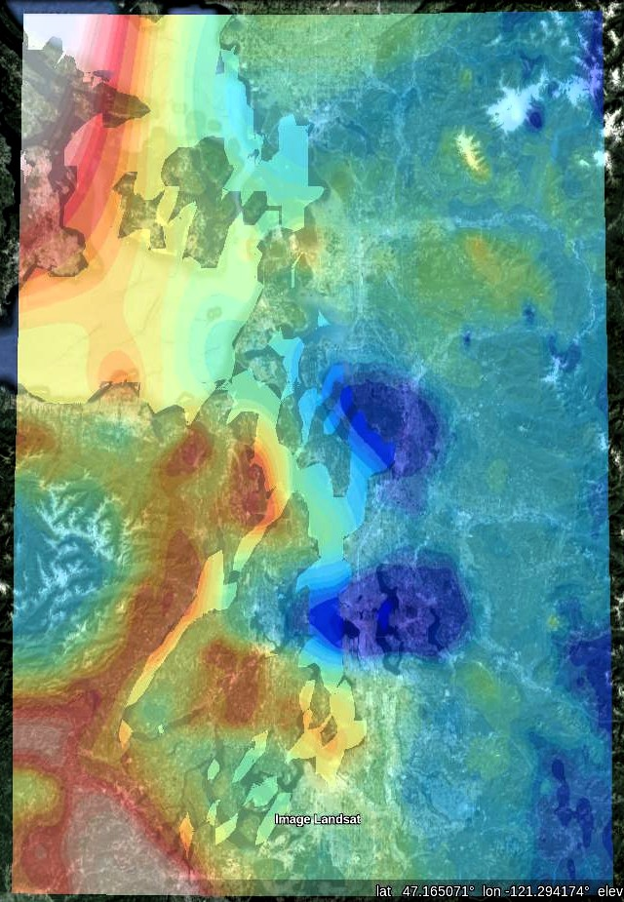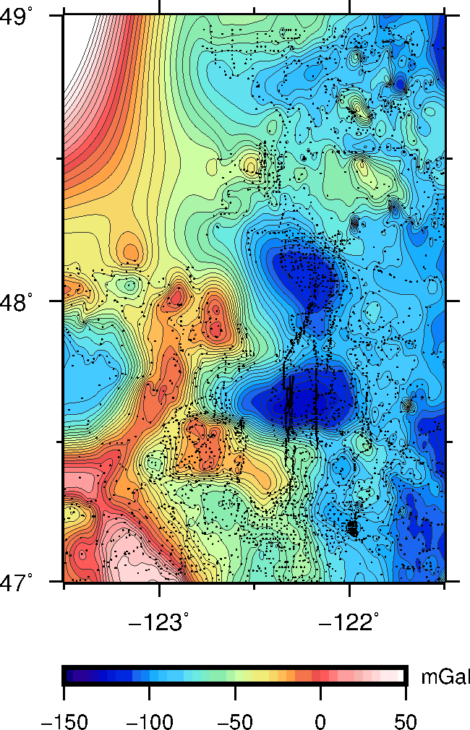 Gravity data was obtained from 47 to 49 degrees North and 121.5 to 123.5 degrees West using the Gravity and Magnetic Extract Utility. The data for latitude, longitude, and gravity values were extracted into their own file and plotted using GMT and PERL to produce the map seen in Figure 2. A PERL script was then used to make a kml file to produce the Google Earth overlay see in in Figure 3. A gravity anomaly ranging from -25 to 25 mGal can be seen in Figures 2 and 3 in the Southwest corner of the maps curving along the base of the Olympic Mountains, corresponding to the brown Ev(c) layer seen in Figure 1. This is the Crescent formation, a unit composed of tholeiitic basalt flows, basaltic flow breccia, filled tubes, and volcanoclastic conglomerate surrounding the marine sediments of the Olympic Mountains (Cjakowski). A smaller amplitude gravity high trending E-W in the Northern part of Figures 2 and 3 can be seen corresponding to the blue Ju unit in Figure 1. This unit is a mix of ultramafic serpentinite, peridotite, and dunite with local variations and metamorphic minerals (Cjakowski). The two large low gravity anomalies of around -120 mGal seen in Figures 2 and 3 is likely a result of glacial deposition into a basin. The full magnetic dataset gridded by Blakely and colleagues was obtained and converted into a WGS84 latitude longitude netCDF grid file before being plotted using GMT and PERL to produce the map seen in Figure 4. As with the Gravity data, a PERL script was then used to make a kml file to produce the 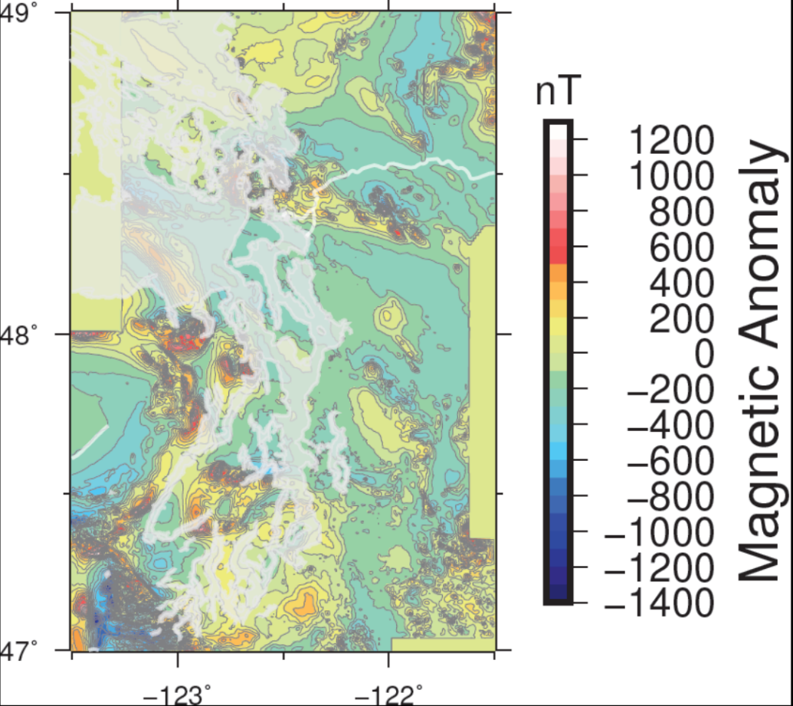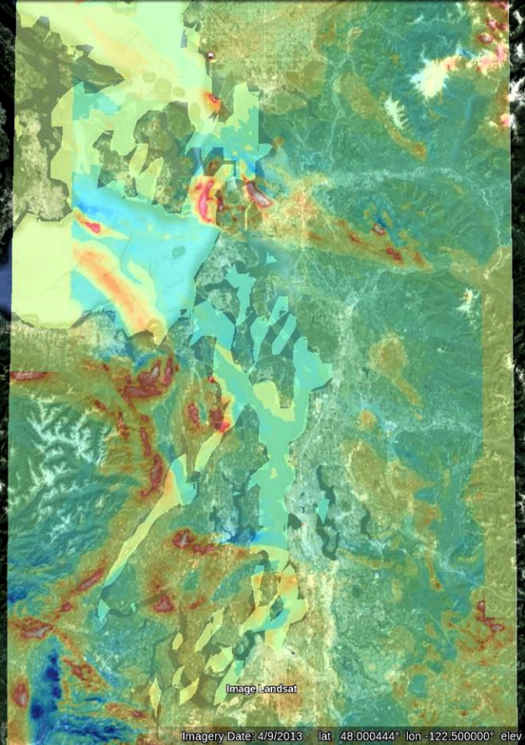Google Earth overlay see in in Figure 5. The Crescent formation gravity high seen in figures 2 and 3 can also be seen to have a high magnetic anomaly associated with it in Figures 4 and 5 of up to around 1000nT at its highest peak and around -500 nT as the lower dipole near this peak. There is also a magnetic anomaly of similar magnitude seen in Figures 4 and 5 with the E-W trending ultramafic units. The high density and magnetic susceptibility of the Crescent formation and these ultramafic units is to be expected, as both have a high iron and magnesium content that gives them higher susceptibility and density. In contrast to this correlation between high magnetic and gravity anomalies for the Crescent formation and ultramafic units, the two large gravity lows seen in the gravity data have no corresponding anomaly in the magnetic data. This means that these low density areas are paramagnetic, and the appearance on only one of these potential field maps shows the importance of checking anomalies with additional methods or data.

Figure 2. Gravity map of the Seattle region. The large anomalous high in the Northwest corner is due to the lack of data across the US-Canada border.

Figure 3. Google Earth overlay of the gravity map from Figure 2. The high gravity anomalies can be seen curved around the Olympic Mountains.

Figure 4. Magnetic map of the Seattle region. The prismatic 0 nT anomalies along the edge of the map are gaps in the magnetic dataset.

Figure 5. Google Earth overlay of the magnetic map from Figure 4.

Bibliography

Blakely, Richard J., Ray E. Wells, and Craig S. Weaver. "Puget Sound Aeromagnetic Maps and Data." USGS. USGS, 1999. Web. 02 May 2016.

Czajkowski, Jessica, and Ian Hubert. "Geologic Information Portal | WA - DNR." Geologic Information Portal | WA - DNR. Washington State Department of Natural Resources, n.d. Web. 02 May 2016.

"Gravity and Magnetic Extract Utility." ArcGIS Viewer for Flex. N.p., n.d. Web. 02 May 2016.